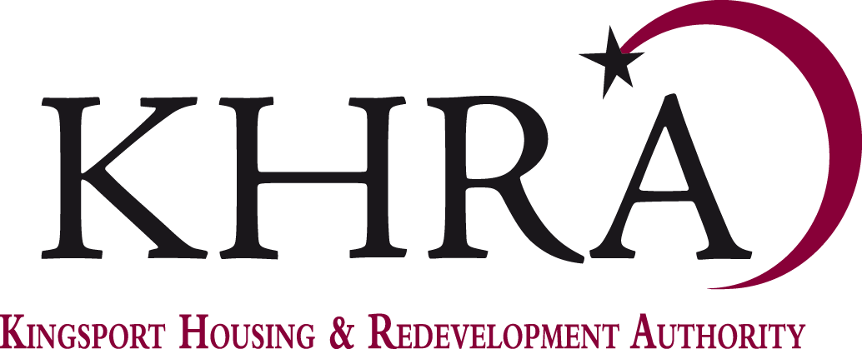

REGULAR MEETING
of the
BOARD OF COMMISSIONERS
Teleconference
Zoom link:
Wednesday, April 15, 2020- 12:00 noon

AGENDA

Call to Order

Roll Call
- Approval of Minutes
  - Regular Meeting February 19, 2020*

- Old Business
  - CDBG* (Guest Speaker)

- Financial Reports
  - 2020 Budget*
  - January Financials*
  - January Financials – Myrtle Street*
  - January Financials- RVP*
  - February Financials*
  - February Financials – Myrtle Street*
  - February Financials- RVP*

- Bill and Communications
- Update on construction progress and relocation

- Staff Reports
Included in Board Packets

- New Business
  - Additional Preferences*

- Announcements
  - Operations Updates: COVID-19
  - Next Board Meeting: May 20, 2020
  - Board Chair Assignment

Adjournment

